Functional Scope Document
Purchase

Author: Anverdheen A
Creation Date: 15-12-2019
Last Updated: 05/01/2020
Document Version : 1.1
Status : Draft Review By : Sajan

Overview
The purpose of this customization is to
- To be captured all the sales process in to the system and Know the Status of each process on Daily basis.

Vendor Master:

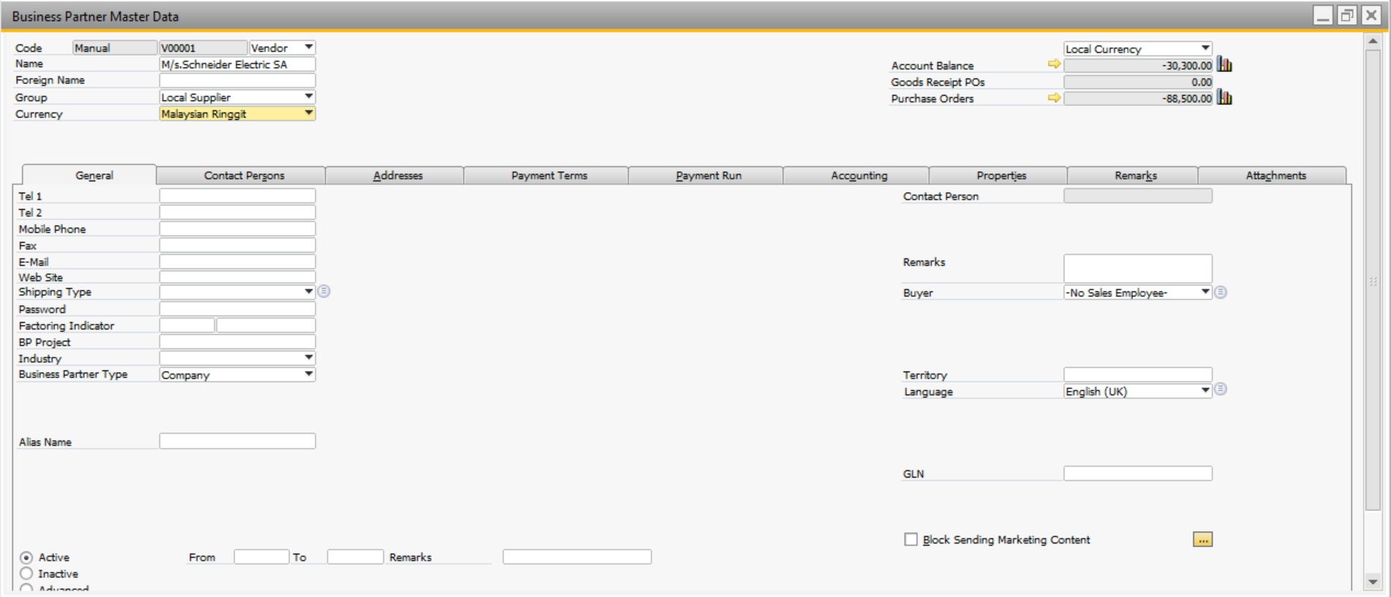

UDF Information
S. No | Field Name | Field type | Valid Values | Validations | SAP | Table
1 | Payment Mode | Alphanumeric | Drop down |  | Manual Selection | OCRD -UDF
2 | Firm Registration certificate | Alphanumeric | Textbox |  | To be Entered | OCRD -UDF
3 | Export Authority Permit Number | Alphanumeric | Textbox |  | To be Entered | OCRD –UDF
4 | FSSAI License number | Alphanumeric | Textbox |  | To be Entered | OCRD –UDF
5 | Distribution Agreement Start Date | Alphanumeric | Textbox |  | To be Entered | OCRD –UDF
6 | Distribution Agreement End Date | Alphanumeric | Textbox |  | To be Entered | OCRD –UDF

Item Master:

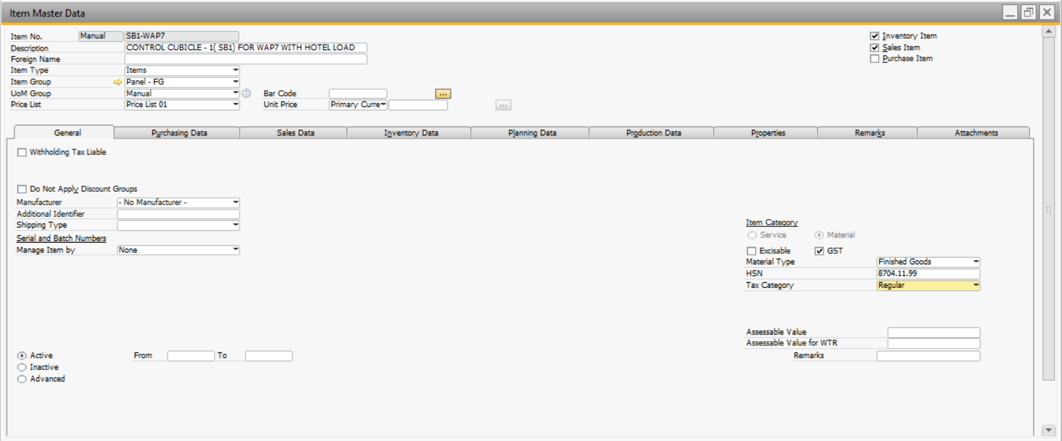

UDF Information
S. No | Field Name | Field type | Valid Values | Validations | SAP | Table
1 | Business/ Principle | Alphanumeric | Drop down |  | Manual Selection | OITM -UDF
2 | Category | Alphanumeric | Drop down |  | Manual Selection | OITM -UDF
3 | Brand | Alphanumeric | Drop down |  | Manual Selection | OITM -UDF
4 | Sub Brand | Alphanumeric | Drop down |  | Manual Selection | OITM -UDF
5 | Market Catalogue | Alphanumeric | Drop down |  | Manual Selection | OITM -UDF
6 | Product Pack | Alphanumeric | Drop down |  | Manual Selection | OITM -UDF
7 | Sub Brand Form | Alphanumeric | Drop down |  | Manual Selection | OITM -UDF
8 | UPC (Unit Per Case) | Numeric | Textbox |  | To be Entered | OITM -UDF
9 | Storage Temperature | Numeric | Textbox |  | To be Entered | OITM -UDF
10 | ABC Indicator ID | Alphanumeric | Textbox |  | To be Entered | OITM -UDF
11 | Danger Level | Numeric | Textbox |  | To be Entered | OITM -UDF
12 | Economic Order Qty | Numeric | Textbox |  | To be Entered | OITM -UDF
13 | Average Level | Numeric | Textbox |  | To be Entered | OITM -UDF
14 | COO | Numeric | Textbox |  | To be Entered | OITM -UDF
15 | Pallet Type | Alphanumeric | Drop down |  | Manual Selection | OITM -UDF
16 | Product Life | Numeric | Textbox |  | To be Entered | OITM -UDF
17 | SU Factor | Numeric | Textbox |  | To be Entered | OITM -UDF
18 | EAN | Numeric | Textbox |  | To be Entered | OITM -UDF
19 | Fragile (Y/N) | Alphanumeric | Drop down |  | Manual Selection | OITM -UDF
20 | Food (Y/N) | Alphanumeric | Drop down |  | Manual Selection | OITM -UDF
21 | ROSIA ID | Numeric | Textbox |  | To be Entered | OITM -UDF
22 | GTIN | Numeric | Textbox |  | To be Entered | OITM -UDF
23 | Is Taxable (Y/N) | Alphanumeric | Drop down |  | Manual Selection | OITM -UDF
24 | Reorder Level | Numeric | Textbox |  | To be Entered | OITM -UDF
25 | Annual Requirement | Numeric | Textbox |  | To be Entered | OITM -UDF
26 | Planning Sys | Alphanumeric | Textbox |  | To be Entered | OITM -UDF
27 | Volume Unit | Numeric | Textbox |  | To be Entered | OITM -UDF
28 | SU Per Case | Numeric | Textbox |  | To be Entered | OITM -UDF
29 | WtGrm | Numeric | Textbox |  | To be Entered | OITM -UDF
30 | CTN Wt | Numeric | Textbox |  | To be Entered | OITM -UDF
31 | ProdPcsKGWt | Numeric | Textbox |  | To be Entered | OITM -UDF
32 | Product Code | Alphanumeric | Textbox |  | To be Entered | OITM -UDF

Provisional Cost Setup (UDO Screen):
- Provisional Cost Master will contain the various cost head involved in the purchase process.
- The cost head fields will capture the provisional cost incurred during the purchase for individuals SKUs
- These provisional cost will be for reference purpose and will be populated onto the sales order
- The actual landed cost and the provisional cost may vary.

Screen Shot Here
- Header Table Information
S. No | Field Name | Field Type | Valid Values | Validations | SAP | Table
1 | Document No | Alphanumeric | Textbox | Mandatory | System Auto Generation | UDO
2 | Document Date | DateTime | Textbox |  | System Date | UDO
3 | Prepared By | Alphanumeric | Textbox |  | Manual Selection from Employee Master | UDO
4 | Checked By | Alphanumeric | Textbox |  | Manual Selection from Employee Master | UDO
5 | Remarks | Alphanumeric | Textbox |  | To be Entered | UDO

- Matrix Table Information
S. No | Field Name | Field Type | Valid Values | Validations | SAP | Table
1 | Item Code | Alphanumeric | Textbox |  | Manual Selection from Item Master | UDO
2 | Item Name | Alphanumeric | Textbox |  | Auto fill based on item code | UDO
3 | LC Charges | Numeric | Textbox |  | To be Entered | UDO
4 | Insurance Charges | Numeric | Textbox |  | To be Entered | UDO
5 | Custom Duty | Numeric | Textbox |  | To be Entered | UDO
6 | Clearing cost Kolkata | Numeric | Textbox |  | To be Entered | UDO
7 | Unloading Expenses | Numeric | Textbox |  | To be Entered | UDO
8 | Document Handling Charges | Numeric | Textbox |  | To be Entered | UDO
9 | Acceptance Cost | Numeric | Textbox |  | To be Entered | UDO
10 | Retirement/Settlement cost | Numeric | Textbox |  | To be Entered | UDO
11 | India/Kolkata-Nepal custom transport cost | Numeric | Textbox |  | To be Entered | UDO
12 | Nepal clearing cost | Numeric | Textbox |  | To be Entered | UDO
14 | Nepal custom -UDN Transport cost | Numeric | Textbox |  | To be Entered | UDO
15 | Detention Cost | Numeric | Textbox |  | To be Entered | UDO
16 | Demurrage Cost | Numeric | Textbox |  | To be Entered | UDO
17 | Other Additional Costs | Numeric | Textbox |  | To be Entered | UDO

Functionality
- To be written here

Annual Business Plan (UDO Screen):
- An annual business will be created at the start of the fiscal year to capture the projection of sales throughout the financial year.
- ABP must be captured at SKU level for each month and must remain static through the year.
- ABP data must be used as a reference data to create monthly sales forecast.

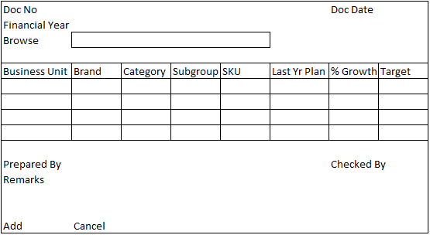

- Header Table Information
S. No | Field Name | Field Type | Valid Values | Validations | SAP | Table
1 | Doc No | Alphanumeric | Textbox | Mandatory | System Auto Generation | UDO
2 | Doc Date (Miti) | DateTime | Textbox |  | System Date | UDO
3 | Financial Year | Alphanumeric | Dropdown |  | To be Selected from posting period | UDO
4 | Browse | Alphanumeric | Textbox |  | Fill the file path based on selection of excel file. | UDO
5 | Prepared By | Alphanumeric | Textbox - CFL |  | To be Selected from Employee master | UDO
6 | Checked By | Alphanumeric | Textbox - CFL |  | To be Selected from Employee master | UDO
7 | Remarks | Alphanumeric | Textbox |  | To be Entered | UDO

- Matrix Table Information
S. No | Field Name | Field Type | Valid Values | Validations | SAP | Table
1 | Business Unit | Alphanumeric | Textbox | Match with respective master | To be Entered | UDO
2 | Brand | Alphanumeric | Textbox | Match with respective master | To be Entered | UDO
3 | Category | Alphanumeric | Textbox | Match with respective master | To be Entered | UDO
4 | Subgroup | Alphanumeric | Textbox | Match with respective master | To be Entered | UDO
5 | SKU | Alphanumeric | Textbox | Match with respective master | To be Entered | UDO
6 | Last Year Plan | Numeric | Textbox | Numeric only | To be Selected | UDO
7 | % of Growth | Percentage | Textbox | Percentage only |  | UDO
8 | Target | Numeric | Textbox | Numeric only |  | UDO

Functionality
- User will upload the Annual business plan data into SAP and will refer whenever required

Purchase Request & Quotation:

S. No | Field Name | Field type | Valid Values | Validations | SAP | Table
1 | PR Type | Alphanumeric | Drop down |  | Manual Selection from UDT | UDF
2 | Purchase Type | Alphanumeric | Drop down |  | Manual Selection from UDT | UDF

Purchase Order:

S. No | Field Name | Field type | Valid Values | Validations | SAP | Table
1 | Business Unit | Alphanumeric | Drop down |  | Manual Selection from UDT | OPOR-UDF
2 | Purchase Type | Alphanumeric | Drop down | (Local/ Import/ Cash) | Manual Selection from UDT | OPOR-UDF
3 | Sub Type | Alphanumeric | Drop down | (Goods/Consumables/Services) | Manual Selection from UDT | OPOR-UDF
4 | Cases | Numeric | Textbox |  | Pick from item master – line level | POR1-UDF
5 | Incoterm | Alphanumeric | Drop down |  | Manual Selection from UDT | OPOR-UDF
6 | Custom entry point | Alphanumeric | Textbox |  | To be Entered | OPOR-UDF
7 | Harmonic code | Alphanumeric | Textbox |  | To be Entered | OPOR-UDF
8 | Insurance Claimable | Alphanumeric | Drop down | (Yes/No) | Manual Selection | OPOR-UDF
9 | Detention/Demurrage Claimable | Alphanumeric | Drop down | (Yes/No) | Manual Selection | OPOR-UDF
10 | Req. Dispatch Date | DateTime | Textbox |  | To be Entered | OPOR-UDF

- Provisional Cost details needs to be included

Pro Forma Invoice (PFI UDO Screen):
- The Pro Forma Invoice will be copied from the purchase order.
- The Pro Forma Invoice will contain the actual quantity the vendor will be able to dispatch and the actual rates.
- The fields of the Pro Forma Invoice will be copied from the purchase order and the quantity and rates will be editable.

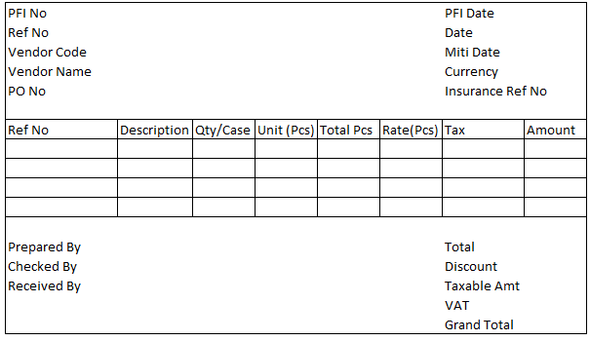

UDF Header Information
S. No | Field Name | Field type | Valid Values | Validations | SAP | Table
1 | PFI No | Alphanumeric | Textbox |  | Auto Generation | UDO
2 | PFI Date | DateTime | Textbox |  | System Date | UDO
3 | Ref No | Alphanumeric | Textbox |  | To Be Entered | UDO
4 | Date | DateTime | Textbox |  | System Date | UDO
5 | Miti Date | DateTime | Textbox |  | Nepali Date | UDO
6 | Vendor Code | Alphanumeric | Textbox | CFL | Manual selection form Vendor master (Trade vendors only) | UDO
7 | Vendor Name | Alphanumeric | Textbox |  | Based on vendor code | UDO
8 | PO No | Alphanumeric | Textbox | CFL | Based on vendor code | UDO
9 | Currency | Alphanumeric | Textbox |  | Based on vendor code | UDO
10 | Insurance Ref No | Numeric | Textbox |  | To be Entered | UDO
11 | Total | Numeric | Textbox |  | Sum of Line Total | UDO
12 | Discount | Numeric | Textbox |  | To be Entered | UDO
13 | Taxable Amount | Numeric | Textbox |  | Total – Discount | UDO
14 | VAT | Numeric | Textbox |  | Sum of Tax Value | UDO
15 | Grand Total | Numeric | Textbox |  | Taxable Amount + VAT | UDO
16 | Prepared By | Alphanumeric | Textbox | CFL | Manual selection from Employee master | UDO
17 | Checked By | Alphanumeric | Textbox | CFL | Manual selection from Employee master | UDO
18 | Received By | Alphanumeric | Textbox | CFL | Manual selection from Employee master | UDO

UDF Matrix Information
S. No | Field Name | Field type | Valid Values | Validations | SAP | Table
1 | Ref No | Alphanumeric | Textbox |  | Auto generation based on header ref. no and line no | UDO
2 | SKU Description | Alphanumeric | Textbox |  | Based on PO No | UDO
3 | Qty/ Case | Numeric | Textbox |  | Based on PO No | UDO
4 | Unit (Pcs) | Numeric | Textbox |  | Based on PO No | UDO
5 | Total Pcs | Numeric | Textbox |  | Based on PO No | UDO
6 | Rate Per Pcs | Numeric | Textbox |  | Based on PO No | UDO
7 | Tax | Numeric | Textbox |  | Based on PO No | UDO
8 | Amount | Numeric | Textbox |  | Based on PO No | UDO

Functionality
- Pro Forma Invoice will be created from the purchase order
- The field from the purchase order will be directly copied to the PFI
- The fields such as quantity, rate and item can be editable
- The PFI will have a mandatory field for the insurance reference number

Letter of Credit (UDO Screen):
- The letter of credit is the mode of payment to vendor in case of import purchases.
- The letter of credit will be created by the bank against the Pro Forma Invoice.
- The screen will be used to track the letter of credit and it’ll show the currently active LC’s and closed LC’s.

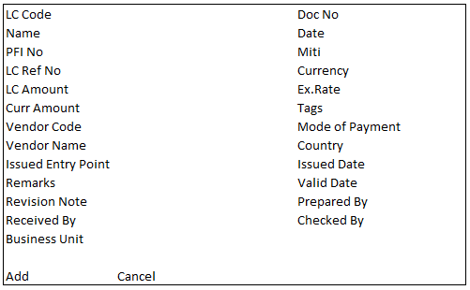

- Header Table Information
S. No | Field Name | Field Type | Valid Values | Validations | SAP | Table
1 | Doc No | Alphanumeric | Textbox | Mandatory | System Auto Generation | UDO
2 | Doc Date | DateTime | Textbox |  | System Date
3 | Miti Date | DateTime | Textbox |  | Nepali Date | UDO
4 | LC Code | Alphanumeric | Textbox |  | To Be Entered | UDO
5 | LC Name | Alphanumeric | Textbox |  | To Be Entered | UDO
6 | PFI No | Alphanumeric | Textbox – CFL |  | Manual Selection from PFI Document list | UDO
7 | LC Ref No | Alphanumeric | Textbox |  | To Be Entered | UDO
8 | LC Amount | Numeric | Textbox |  | To Be Entered | UDO
9 | Currency | Alphanumeric | Textbox |  | From PFI Document | UDO
10 | Ex. Rate | Decimal | Textbox |  | From Exchange rate | UDO
11 | Currency Amount | Decimal | Textbox |  | LC Amount * Ex. Rate | UDO
12 | Tags | Alphanumeric | Textbox |  | To be Entered | UDO
13 | Vendor Code | Alphanumeric | Textbox |  | From PFI No
14 | Vendor Name | Alphanumeric | Textbox |  | From PFI No
15 | Mode of Payment | Alphanumeric | Dropdown |  | Manual selection from UDT
16 | Country | Alphanumeric | Textbox |  | Based on vendor master
17 | Issued Entry Point | Alphanumeric | Textbox |  | To be Entered | UDO
18 | Issued Date | DateTime | Textbox |  | To be Entered | UDO
19 | Valid Date | DateTime | Textbox |  | To be Entered | UDO
20 | Revision Note | Alphanumeric | Textbox |  | To be Entered | UDO
21 | Business Unit | Alphanumeric | Dropdown |  | Manual selection from UDT | UDO
22 | Prepared By | Alphanumeric | Textbox –CFL |  | Manual selection form Employee master | UDO
23 | Checked By | Alphanumeric | Textbox –CFL |  | Manual selection form Employee master | UDO
24 | Received By | Alphanumeric | Textbox –CFL |  | Manual selection form Employee master | UDO
25 | Remarks | Alphanumeric | Textbox |  | To be Entered | UDO

Functionality
- The LC screen will captured all the LC related details opened against the PFI
- The LC screen will have option to filter out open LC’s
- The LC should have the reference number of the Pro Forma Invoice as well the commercial invoice once created
- The LC screen should have the LC number, opening date and expiry date
- The LC screen should capture any amendment made to the LC listing the date, cost and reason of amendment

Commercial Invoice (UDO Screen):
- The commercial invoice is created once the dispatch from the vendor is done.
- The commercial invoice will be copied from the commercial invoice.
- The fields of the PFI and CI will be identical as the Pro Forma Invoice is the base for Commercial Invoice.

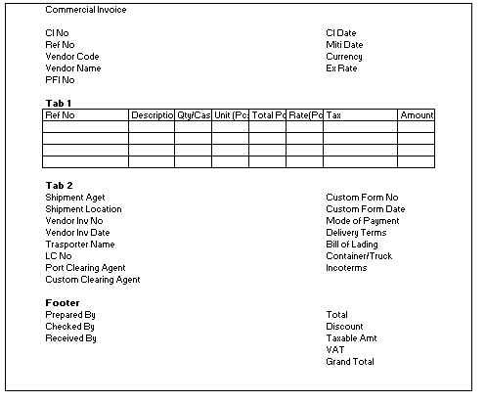

UDF Header Information
S. No | Field Name | Field type | Valid Values | Validations | SAP | Table
1 | CI No | Alphanumeric | Textbox |  | Auto Generation | UDO
2 | CI Date | DateTime | Textbox |  | System Date | UDO
3 | Ref No | Alphanumeric | Textbox |  | To Be Entered | UDO
4 | Miti Date | DateTime | Textbox |  | Nepali Date | UDO
5 | Vendor Code | Alphanumeric | Textbox | CFL | Manual selection form Vendor master (Trade vendors only) | UDO
6 | Vendor Name | Alphanumeric | Textbox |  | Based on vendor code | UDO
7 | PFI No | Alphanumeric | Textbox | CFL | Based on vendor code | UDO
8 | Currency | Alphanumeric | Textbox |  | Based on vendor code | UDO
9 | Ex. Rate | Decimal | Textbox |  | From Ex. Rate master | UDO
10 | Total | Numeric | Textbox |  | Based on PFI Document | UDO
11 | Discount | Numeric | Textbox |  | Based on PFI Document | UDO
12 | Taxable Amount | Numeric | Textbox |  | Based on PFI Document | UDO
13 | VAT | Numeric | Textbox |  | Based on PFI Document | UDO
14 | Grand Total | Numeric | Textbox |  | Based on PFI Document | UDO
15 | Prepared By | Alphanumeric | Textbox | CFL | Based on PFI Document | UDO
16 | Checked By | Alphanumeric | Textbox | CFL | Based on PFI Document | UDO
17 | Received By | Alphanumeric | Textbox | CFL | Based on PFI Document | UDO
18 | Remarks | Alphanumeric | Textbox |  | To be Entered | UDO

UDF Matrix Information (Tab-1)
S. No | Field Name | Field type | Valid Values | Validations | SAP | Table
1 | Ref No | Alphanumeric | Textbox |  | Auto generation based on header ref. no and line no | UDO
2 | SKU Description | Alphanumeric | Textbox |  | Based on PO No | UDO
3 | Qty/ Case | Numeric | Textbox |  | Based on PO No | UDO
4 | Unit (Pcs) | Numeric | Textbox |  | Based on PO No | UDO
5 | Total Pcs | Numeric | Textbox |  | Based on PO No | UDO
6 | Rate Per Pcs | Numeric | Textbox |  | Based on PO No | UDO
7 | Tax | Numeric | Textbox |  | Based on PO No | UDO
8 | Amount | Numeric | Textbox |  | Based on PO No | UDO

UDF Information (Tab-2)
S. No | Field Name | Field type | Valid Values | Validations | SAP | Table
1 | Shipment Agent | Alphanumeric | Textbox |  | To be Entered/ Vendor master | UDO
2 | Shipment Location | Alphanumeric | Textbox |  | To be Entered | UDO
3 | Vendor Inv. No | Alphanumeric | Textbox |  | To be Entered | UDO
4 | Vendor Inv. Date | DateTime | Textbox |  | To be Entered | UDO
5 | LC No | Alphanumeric | Textbox |  | To be Entered | UDO
6 | Custom Form No | Alphanumeric | Textbox |  | To be Entered | UDO
7 | Custom Form Date | Alphanumeric | Textbox |  | To be Entered | UDO
8 | Mode of Payment | Alphanumeric | Dropdown |  | Manual Selection | UDO
9 | Delivery Terms | Alphanumeric | Textbox |  | To be Entered | UDO
10 | Bill of Lading | Alphanumeric | Textbox |  | To be Entered | UDO
11 | Container/ Truck | Alphanumeric | Textbox |  | To be Entered | UDO
12 | Incoterms | Alphanumeric | Textbox |  | To be Entered | UDO
13 | Port clearing Agent | Alphanumeric | Textbox |  | To be Entered | UDO
14 | Custom Clearing Agent | Alphanumeric | Textbox |  | To be Entered | UDO

Functionality
- Commercial Invoice will be based on the Pro Forma Invoice
- The commercial invoice fields will be copied from the Pro Forma Invoice
- The commercial invoice will contain the exact shipment details listing the exact quantity of goods dispatched by the vendor
- The commercial invoice should have a reference LC and PFI number
- The fields of commercial invoice will be editable
- The commercial Invoice will contain all custom and transport related details.

Shipment Tracking (UDO Screen):
- The shipment tracking screen should capture the details of the inbound shipment upon dispatch from the vendor
- The shipment tracking screen will give the tracking information of the shipment based on the update information in the Commercial Invoice.

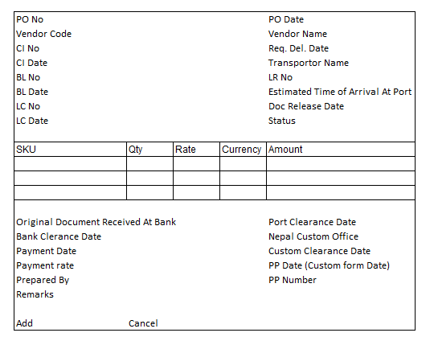

UDF Header Information
S. No | Field Name | Field type | Valid Values | Validations | SAP | Table
1 | PO No | Alphanumeric | Textbox – CFL |  | Manual selection from open PO list | UDO
2 | PO Date | DateTime | Textbox |  | Based on PO No | UDO
3 | Miti Date | DateTime | Textbox |  | Nepali Date | UDO
4 | Vendor Code | Alphanumeric | Textbox |  | Based on PO No | UDO
5 | Vendor Name | Alphanumeric | Textbox |  | Based on vendor code | UDO
6 | CI No | Alphanumeric | Textbox |  | Based on PO No | UDO
7 | CI Date | DateTime | Textbox |  | Based on PO No | UDO
8 | BL No | Alphanumeric | Textbox |  | To be Entered | UDO
9 | BL Date | DateTime | Textbox |  | To be Entered | UDO
10 | LC No | Alphanumeric | Textbox |  | To be Entered | UDO
11 | LC Date | DateTime | Textbox |  | To be Entered | UDO
12 | Req. Del. Date | DateTime | Textbox |  | To be Entered | UDO
13 | Transporter Name | Alphanumeric | Textbox – CFL |  | Manual selection from vendor master | UDO
14 | LR No | Alphanumeric | Textbox |  | To be Entered | UDO
15 | Est. Time of Arrival at Port | DateTime | Textbox |  | To be Entered | UDO
16 | Doc Release Date | DateTime | Textbox |  | To be Entered | UDO
17 | Status | Alphanumeric | Dropdown | (Open/ Close) | Manual selection | UDO
18 | Orig. Doc. Rec. at Bank | DateTime | Textbox |  | To be Entered | UDO
19 | Bank Clearance Date | DateTime | Textbox |  | To be Entered | UDO
20 | Payment Date | DateTime | Textbox |  | To be Entered | UDO
21 | Payment Rate | Numeric | Textbox |  | To be Entered | UDO
22 | Port Clearance Date | DateTime | Textbox |  | To be Entered | UDO
23 | Nepal Custom Office | DateTime | Textbox |  | To be Entered | UDO
24 | Custom Clearance Date | DateTime | Textbox |  | To be Entered | UDO
25 | PP No | Alphanumeric | Textbox |  | To be Entered | UDO
26 | PP Date | DateTime | Textbox |  | To be Entered | UDO

UDF Matrix Information
S. No | Field Name | Field type | Valid Values | Validations | SAP | Table
1 | SKU Description | Alphanumeric | Textbox |  | Based on PO No | UDO
2 | Quantity | Numeric | Textbox |  | Based on PO No | UDO
3 | Rate | Numeric | Textbox |  | Based on PO No | UDO
4 | Currency | Alphanumeric | Textbox |  | Based on PO No | UDO
5 | Amount | Numeric | Textbox |  | Based on PO No | UDO

Functionality
- The shipment tracking screen will give track of the inbound shipment after dispatch from vendor
- The shipment tracking screen will be based on the commercial invoice in which the shipment information will be updated
- The shipment tracking screen will not contain any price or rate details of the inbound shipment
- The shipment tracking of a shipment should contain the reference number to its respective LC and PFI

Goods Receipt PO:
- GRN shall be created based on the PO and CI by Warehouse team and will be copied from the Commercial invoice
- GRN should have the provision to enter the quantity of damaged and short/excess quantity received at the warehouse
- The damaged or short quantity should have the provision to be marked as claimable or non-claimable
- In case of claimable damages or shortage the respective claim management team should be alerted
- Bin location recommendation should be generated by system during GRN
- Barcode generation functionality should be integrated

UDF Information
S. No | Field Name | Field type | Valid Values | Validations | SAP | Table
1 | Qty Conditions | Alphanumeric | Dropdown | (Normal/ Damage/ Shortage/ Excess) | Manual selection | UDO
2 | Claim Type | Alphanumeric | Dropdown | (Claimable/ Non Claimable) | Manual selection | UDO
3 | Insured Qty | Alphanumeric | Dropdown | (Yes/No) | Manual selection | UDO
4 | CI Qty | Numeric | Textbox |  | Copy from Base document | UDO
5 | PFI Qty | Numeric | Textbox |  | Copy from Base document | UDO

Functionality
- GRN will go through approval of the user who created the purchase order.
- Received Qty will be stored in warehouse in the respective bin location
- Approval process should be setup for GRN document
- System should recommend the bin location upon GRPO of the inbound shipment
- The provision to enter the damaged, short and excess goods should be provided to the user
- The damage and short quantity should be marked as claimable or non- claimable by the user
- The bin allocation of goods received should be based on: Default bin, Current bin and
Historic bin location
- Barcode generation will be done for individual case during the GRN process.

A/P Credit Memo:

UDF Information
S. No | Field Name | Field type | Valid Values | Validations | SAP | Table
1 | Return Type | Alphanumeric | Dropdown |  | Manual selection | UDO
2 | Reason for Return | Alphanumeric | Dropdown |  | Manual selection from UDT | UDO

